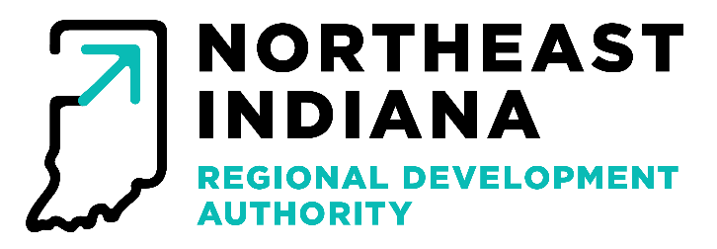
MEETING MINUTES
December 9th, 2025

In Attendance: Andrew Briggs, Jeff Turner, Gene Donaghy

Staff in Attendance: Michael Galbraith, Jacob Ihrie, Erin Whittle, Andrew Boxberger, Alex Platte

Others in attendance: Lisa Long, Linda Golden, Matthew Golden

Meeting Location: 200 East Main Street, Suite 910, Fort Wayne, IN 46802

Call to Order
Jeff Turner, as temporary Chair, called the meeting to order at 2:05 p.m.

Approval of Minutes
Minutes from the November meetings were presented to the Board. Jeff Turner asked for a motion to approve the minutes. Gene Donoghy made the motion to approve the minutes. Andrew Brigg seconded. The motion passed unanimously.

Claims
Staff presented the claims to the board. Jeff Turner asked for a motion to approve the claims. Andrew Briggs made the motion to accept the claims. Gene Donoghy seconded the motion. The motion passed unanimously.

Financial Report
Staff presented the board with the monthly financial report. Jeff Turner asked for a motion to approve the financial report. Andrew Briggs made the motion to accept the financial report. Gene Donaghy seconded. The motion passed unanimously.

SDC Disbursement Approvals
Jacob Ihrie requested disbursements to be approved for the following projects approved by the Strategic Development Commission; a $50,000 payment to NEI for work performed towards the regional SWOT Analysis, and Club 720 in the amount of $31,666.66. Jeff Turner asked for a motion to approve the disbursements. Gene Donaghy made the motion to approve the disbursements, Andrew Briggs seconded. The Motion passed unanimously.

READI Program — Update
Jacob Ihrie gave updates for the READI program, the region is tracking well on percentage of funds disbursed. With a total of $39,560,000 out into the awarded programs, with approximately $2,000,000 more pending.

READI Program – Disbursements Approvals and Pre-approvals
No disbursements this month.

Jacob Ihrie presented a disbursement approval for Topeka Housing in the amount of $380,407.55. Jeff Turner asked for a motion to approve the disbursement. Andrew Briggs made the motion to approve the disbursements, Jeff Turner seconded. The Motion passed unanimously.

READI 2.0 –
Grant Agreements – The Fairfield, The Auburn, The Landing Exchange
The board reviewed the details of the grant agreement and Jeff Turner requested a motion. Andrew Briggs made the motion to approve the Grant Agreement with the Fairfield, designate a single signer for the agreement, and to table The Auburn and the Landing Exchange to the next month. Gene Donaghy seconded. The motion passed unanimously.

Victory Gardens, second presentation
Linda Golden presented the requested materials to the board, as per their request. After discussion, Jeff Turner made the request for a motion. Gene Donaghy made the motion to approve a forgivable in the amount of $1,089,913.00 to the project. Andrew Briggs seconded. The motion passed unanimously.

Adjournment
With no other new business, Jeff Turner made a motion to adjourn, Andrew Briggs seconded. The motion passed adjourning the meeting at 3:35 p.m.

