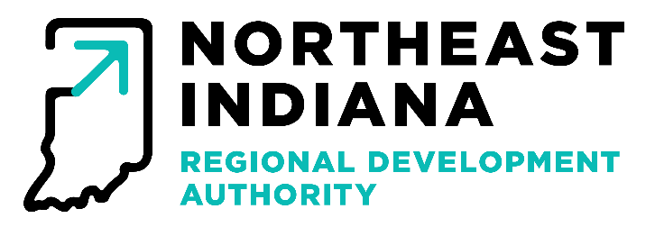
MEETING MINUTES
January 13th, 2026

In Attendance: Andrew Briggs, Jeff Turner, Gene Donaghy, Bob Marshall, James Khan

Staff in Attendance: Michael Galbraith, Jacob Ihrie, Erin Whittle, Andrew Boxberger, Alex Platte

Others in attendance: Nicholas Kappas, Zach Woolard (virtual), Kevin Menard (virtual), Johnathan Liest

Meeting Location: 200 East Main Street, Suite 910, Fort Wayne, IN 46802

Call to Order
James Kahn called the meeting to order at 2:05 p.m.

Approval of Minutes
Minutes from the December meeting were presented to the Board. James Khan
asked for a motion to approve the minutes. Jeff Turner made the motion to approve the minutes. Andrew Brigg seconded. The motion passed unanimously.

Claims
Staff presented the claims to the board. James Khan asked for a motion to approve the claims. Gene Donaghy made the motion to accept the claims. Andrew Briggs seconded the motion. The motion passed unanimously.

Financial Report
Staff presented the board with the monthly financial report. James Khan asked for a motion to approve the financial report. Gene Donaghy made the motion to accept the financial report. Andrew Briggs seconded. The motion passed unanimously.

SDC Disbursement Approvals
Jacob Ihrie requested disbursements to be approved for the following projects approved by the Strategic Development Commission; two disbursements for Club720 in the amounts of $31,666.66 and $75,000, Grow Allen in the Amount of $125,000, Amani Family Services for $20,000, and Wabash County Fellowship in the amount of $33,750. James Khan asked for a motion to approve the disbursements. Bob Marshall made the motion to approve the disbursements, Andrew Briggs seconded. The Motion passed unanimously.

READI Program — Update
Jacob Ihrie gave updates for the READI program, the region is tracking well on percentage of funds disbursed. With a total of $39,560,000 out into the awarded programs, with approximately $2,000,000 more pending.

READI Program – Disbursements Approvals and Pre-approvals
Jacob Ihrie presented disbursement 1 for for the Rivergreen project this will be the only disbursement from the project, and the final disbursement for the arts plan in the amount $25,090. James Kahn requested a motion to approve the disbursements. Jeff Turner made the motion to approve the disbursements, Gene Donaghy seconded. The motion passed unanimously.

READI 2.0 –

Grant Agreements – The Landing Exchange, The Auburn
Landing Exchange –
The Board moved forward with approving the grant agreement with no substantive changes. James Khan requested a motion to approve the grant agreement under those considerations. Jeff Turner made the motion. Bob Marshall seconded. The motion passed unanimously.

The Auburn
The project owners presented their request to alter the approval to reflect the following to accept the following conditions; the grants forgivable portion will follow the forgiveness guidelines provided in lockstep with the City of Auburn’s economic development agreement, and the mode of payment will based on a preferred return with the remainder of the non-forgivable portion being due on sale if before 7 years, or at 10 years, whichever comes first. James Khan requested a motion to reflect the request presented. Bob Marshall made the motion to approve. Gene Donaghy seconded the motion. The motion passed unanimously.

Election of Officers
Jeff turner made the motion to nominate Bob Marshall as President, Andrew Briggs as Vice President, and Gene Donaghy as secretary. James Kahn seconded that motion. The motion passed unanimously.

Adjournment
With no other new business, James Khan made a motion to adjourn, Andrew Briggs seconded. The motion passed adjourning the meeting at 3:55pm.

